SHEET -10 – PROCESS MANAGEMENT

1. Use the ps cmd to list down all the processes ,pipe it to more or less for paging
   1. ps -e

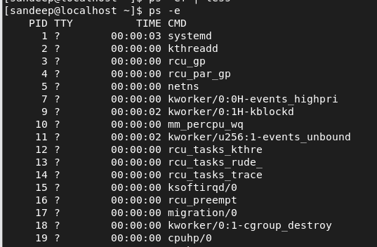

* 1. ps -ef

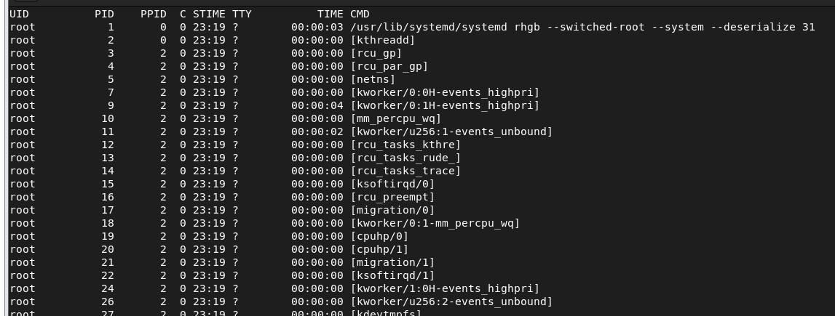

* 1. ps -f

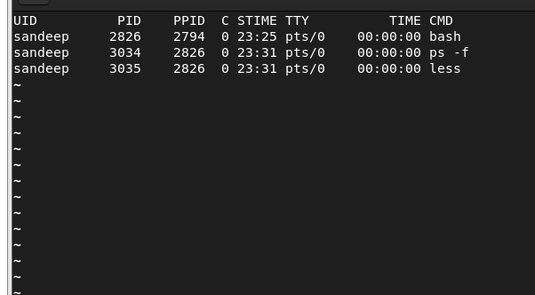

* 1. ps -aux

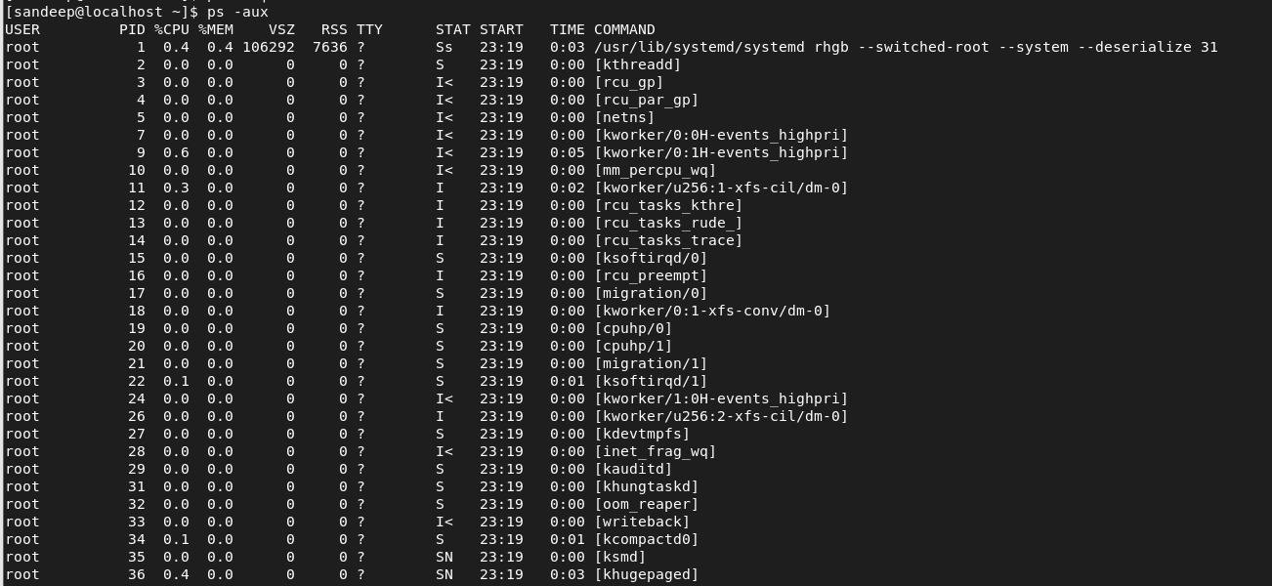

* 1. ps -u username
     1. ps -u root

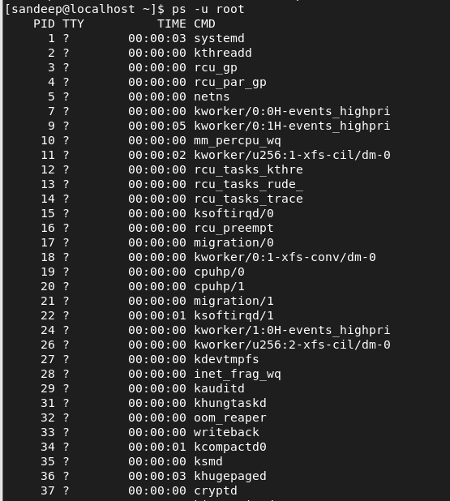

* + 1. ps -u yourname

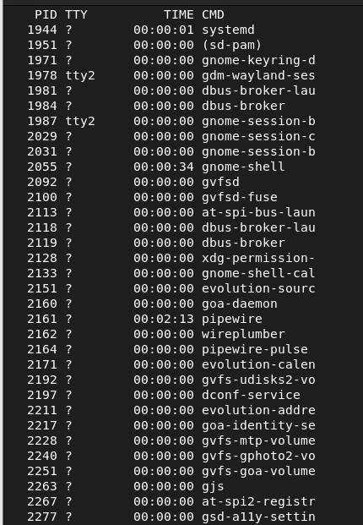

1. find the pid of bash
   1. pidof bash



* 1. run ps -f (pidofbash)

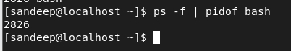

* 1. pgrep bash / pgrep -l bash

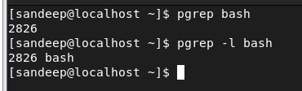

1. run cat > processfile
   1. input some text and suspend or stop the process using ctrl +z

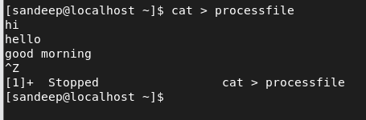

* 1. get the pid of cat using pidof or pgrep cmd



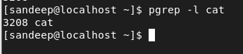

* 1. list the process details using ps -f (pidofcat)

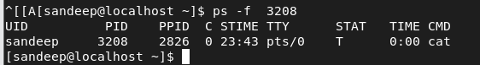

* 1. Now start the cat process using fg cmd

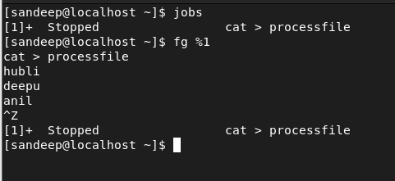

* 1. Check bg jobs if any using jobs cmd.

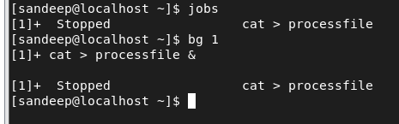

1. Use vi to create a little text file. Suspend vi in background.

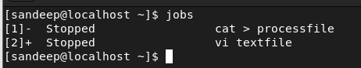

1. Verify with jobs that vi is suspended in background.

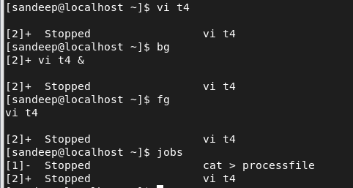

1. Start sleep 100 process, suspend or terminate before it finishes
   1. Get the details of sleep process using ps -f pidsleep

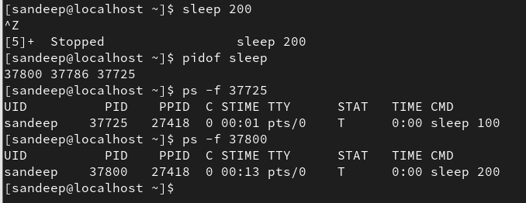

* 1. Start the sleep cmd in bg.

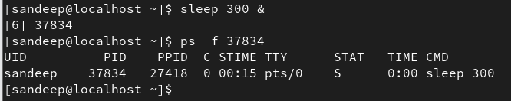

1. Start two long sleep processes in background.

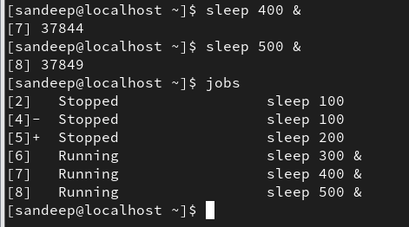

1. Display all jobs in background



1. Use pstree cmd to lists all process of bash – pstree pidofbash

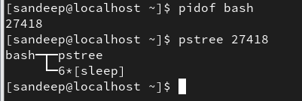

1. Customise the output columns of ps cmd using
   1. ps -eo user,uid,pcpu,pmem,cmd

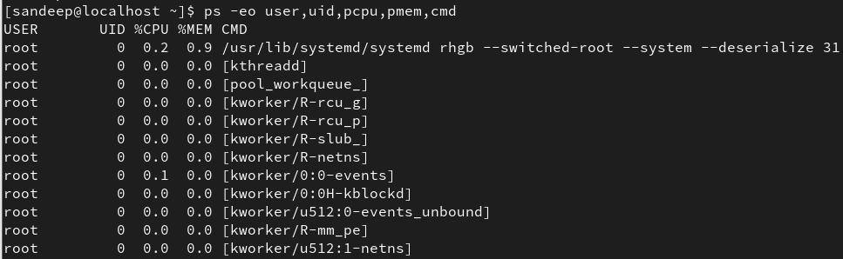

* 1. ps -eo user=username,uid=userid,pcpu=cpu,pmem=mem,cmd=command

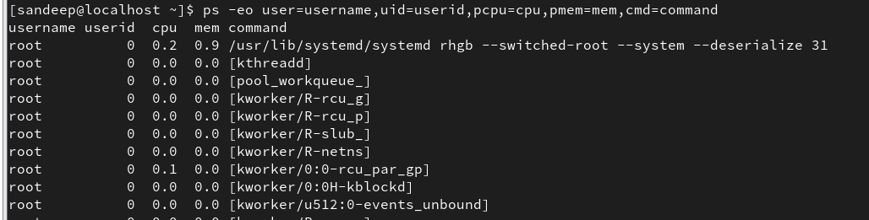

* 1. ps axo user,uid,cmd,stat,pid,ppid

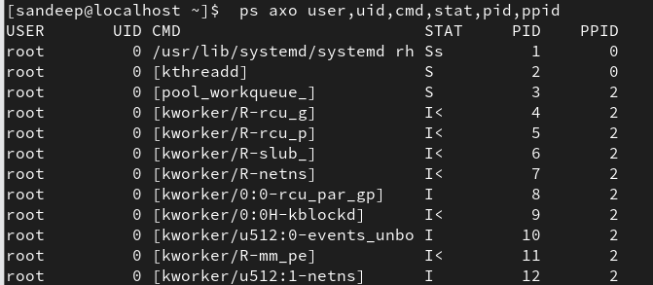

1. Put one of the sleep process in foreground

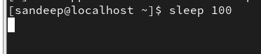

1. Kill one of the sleep process
   1. Use job id to kill sleep process – kill %[jobid]

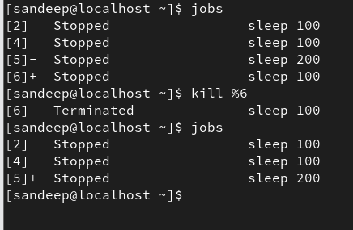

* 1. Use pid of sleep – kill pid

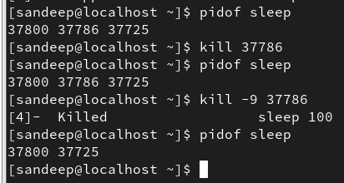

1. Kill the vi process using pkill cmd

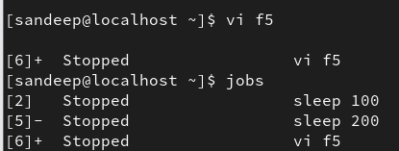

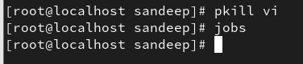

1. Use killall to kill all sleep process

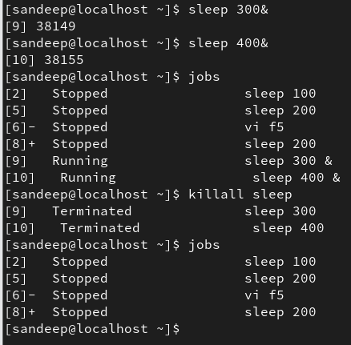

1. Use kill -9 to kill the bash process
2. Open 2 terminals and start 2 long sleep processes. (provide screen shots for grep cmd alone in both cases )

a. Put them in bg

* 1. Check the jobs in bg

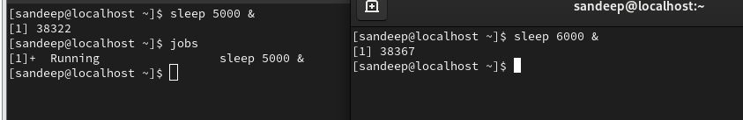

* 1. In 1st terminal run -> ps -ef | grep sleep and observe

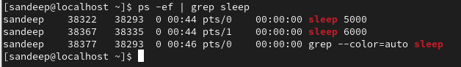

* 1. Now close the second terminal and run grep cmd again to check and understand.

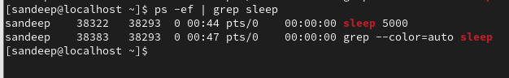

* 1. Inorder to run a process without a terminal we use nohup (hangup cmd)
     1. Start sleep process with nohup sleep 100 &
     2. In 1st terminal run -> ps -ef | grep sleep and observe



* + 1. Now close the second terminal and run grep cmd again to check and understand.

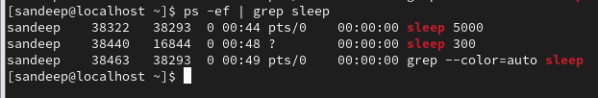

* 1. Observe a new file nohup.out is created cat and chk



1